2027 4/5 Calendars
 | 2027
Line | Starting date in January 2027 | Number of Shifts | Number of additional hours ”pick up” needed
H | 1 | 160 | 60
I | 2 | 160 | 60
A | 3 | 161 | 48.75
B | 4 | 162 | 37.5
C | 5 | 163 | 26.25
D | 6 | 164 | 15
E | 7 | 163 | 26.25
F | 8 | 162 | 37.5
G | 9 | 161 | 48.75

Note: 1950 hours is your full time commitment. By agreeing to work a full time position you and the hospital are stating that you will work 1950 hours in a year, and they will pay sick time, vacation, benefits in return.

Pensionable Shifts 2027: Line H (9)
**Pensionable year (Dec 28,2026 - Dec 26, 2026)
2026 Pensionable Shifts: December 28, 29, 30, 31

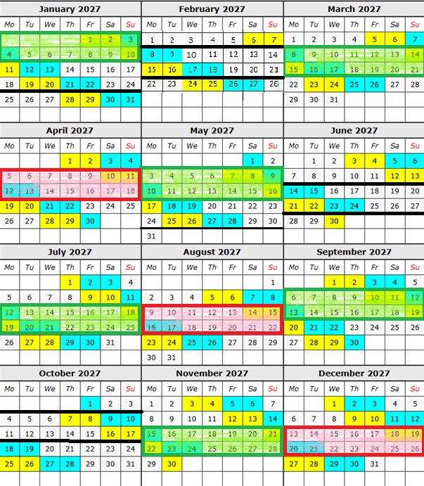
⃞ 5 shift pays ⃞ 4 shift pays
Add STAT/OTO to short pays in Kronos

160 shifts = 1800 hours
Plus 12 STAT = 90 hours
60 pickup hours needed

Pensionable Shifts 2027: Line I (7)
**Pensionable year (Dec 28,2026 - Dec 26, 2026)
2026 Pensionable Shifts: December 28, 29, 30, 31
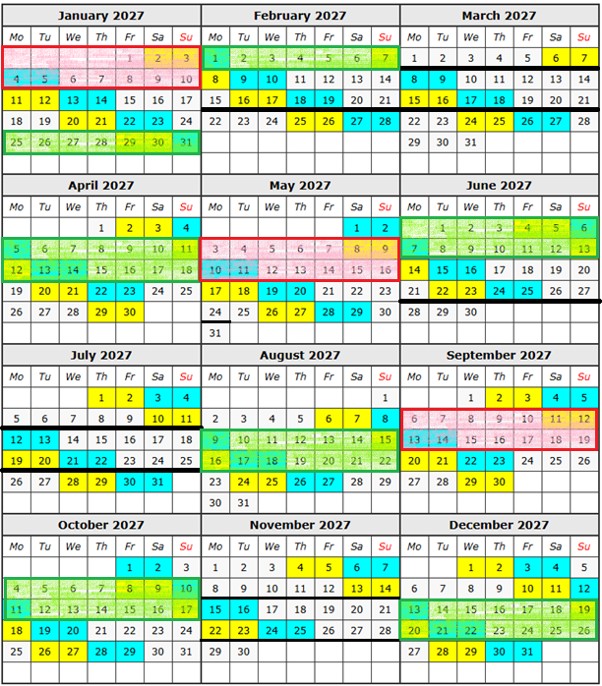

⃞ 5 shift pays ⃞ 4 shift pays
Add STAT/OTO to short pays in Kronos

160 shifts = 1800 hours
Plus 12 STAT = 90 hours
60 pickup hours needed

Pensionable Shifts 2027: Line A (5)
**Pensionable year (Dec 28,2026 - Dec 26, 2026)
2026 Pensionable Shifts: December 28, 29, 30, 31

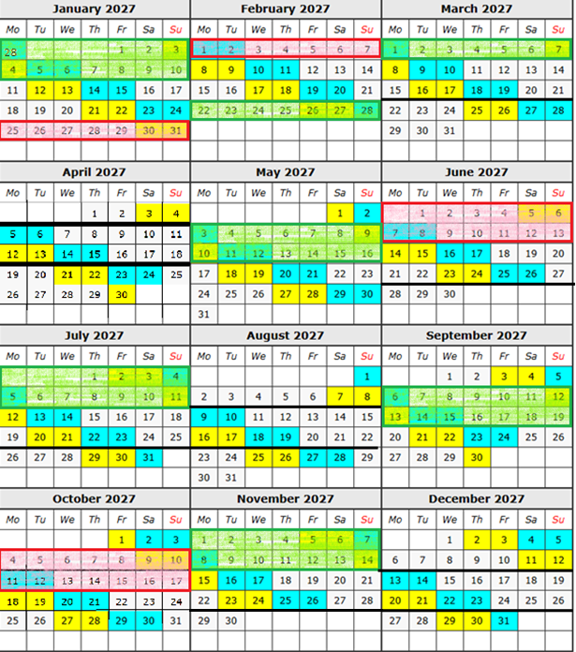

⃞ 5 shift pays ⃞ 4 shift pays
Add STAT/OTO to short pays in Kronos

161 shifts = 1811.25 hours
Plus 12 STAT = 90 hours
48.75 pickup hours needed

Pensionable Shifts 2027: Line B (3)
**Pensionable year (Dec 28,2026 - Dec 26, 2026)
2026 Pensionable Shifts: December 28, 29, 30, 31
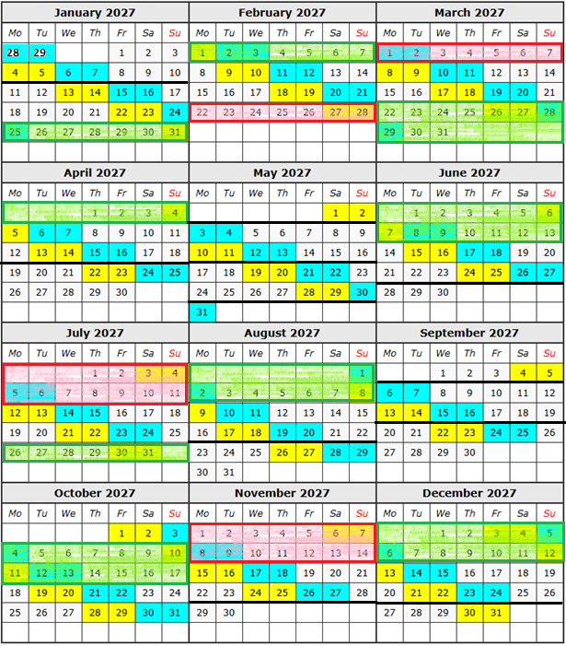

⃞ 5 shift pays ⃞ 4 shift pays
Add STAT/OTO to short pays in Kronos

162 shifts = 1822.5 hours
Plus 12 STAT = 90 hours
37.5 pickup hours needed

Pensionable Shifts 2027: Line C (1)
**Pensionable year (Dec 28,2026 - Dec 26, 2026)
2026 Pensionable Shifts: December 28, 29, 30, 31
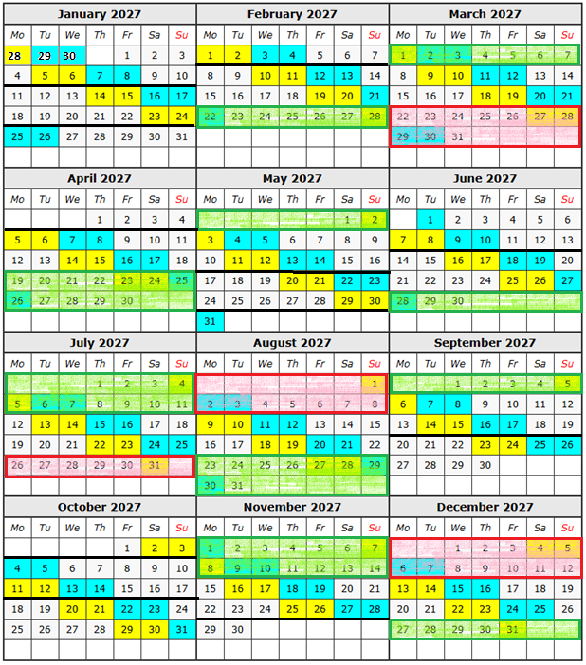

⃞ 5 shift pays ⃞ 4 shift pays
Add STAT/OTO to short pays in Kronos

163 shifts = 1833.75 hours
Plus 12 STAT = 90 hours
26.25 pickup hours needed

Pensionable Shifts 2027: Line D (8)
**Pensionable year (Dec 28,2026 - Dec 26, 2026)
2026 Pensionable Shifts: December 28, 29, 30, 31
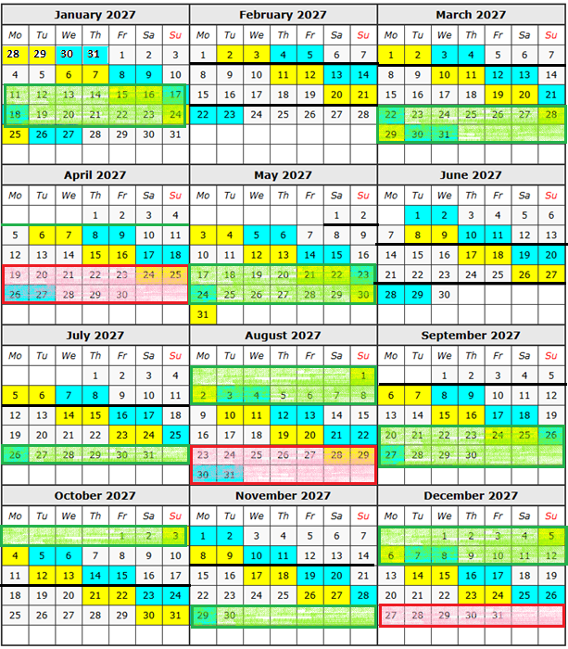

⃞ 5 shift pays ⃞ 4 shift pays
Add STAT/OTO to short pays in Kronos

164 shifts = 1845 hours
Plus 12 STAT = 90 hours
15 pickup hours needed

Pensionable Shifts 2027: Line E (6)
**Pensionable year (Dec 28,2026 - Dec 26, 2026)
2026 Pensionable Shifts: December 28, 29, 30, 31

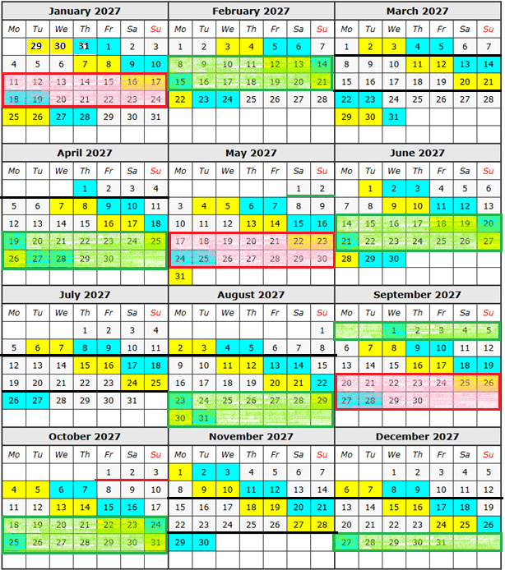
⃞ 5 shift pays ⃞ 4 shift pays
Add STAT/OTO to short pays in Kronos

163 shifts = 1833.75 hours
Plus 12 STAT = 90 hours
26.25 pickup hours needed
Pensionable Shifts 2027: Line F (4)
**Pensionable year (Dec 28,2026 - Dec 26, 2026)
2026 Pensionable Shifts: December 28, 29, 30, 31

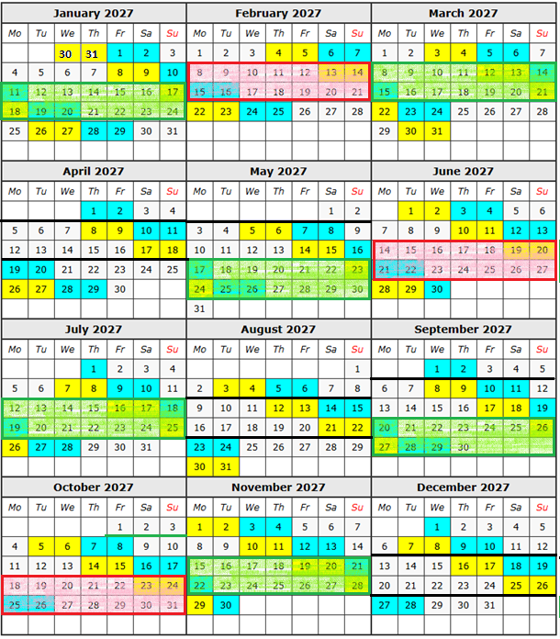

⃞ 5 shift pays ⃞ 4 shift pays
Add STAT/OTO to short pays in Kronos

162 shifts = 1822.5 hours
Plus 12 STAT = 90 hours
37.5 pickup hours needed

Pensionable Shifts 2027: Line G (2)
**Pensionable year (Dec 28,2026 - Dec 26, 2026)
2026 Pensionable Shifts: December 28, 29, 30, 31
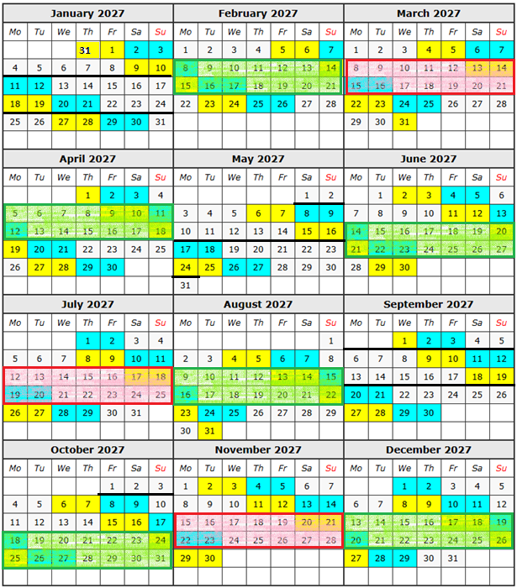

⃞ 5 shift pays ⃞ 4 shift pays
Add STAT/OTO to short pays in Kronos

161 shifts = 1811.25 hours
Plus 12 STAT = 90 hours
48.75 pickup hours needed

